

**Revolutionizing Connectivity:**

An In-Depth Exploration of

Information and Communication

Technologies

(TIC)

Project realized by: Zineb Ouled Laid, Allag Ines, Farah Laggoune, Khoujabach Abdelmouhaimine

‘Group 63’

TABLE OF CONTENTS

* The introduction
* Information and Communication Technologies (TIC)
* Google Services
* Google Drive
* Git and GitHub: Architecting Code Collaboration
* Microsoft Tools
* Accessibility tools in Microsoft Office address
* Artificial Intelligence: A New Landscape or a New Era
* THE BLOCKCHAIN TECHNOLOGY
* Augmented Reality: Transforming User Experience
* Conclusion



Introduction :

**In the rapidly evolving landscape of Information and Communication Technologies (ICT), we find ourselves at the intersection of innovation and connectivity. The advent of ICT has not only transformed the way we communicate**

**but has also become an integral part of how we access, process, and disseminate information in our modern**

**society.As we delve into the depths of this digital era, it is impossible to overlook the profound impact**

**of technology giants like Google and Microsoft. These industry leaders have introduced a spectrum of services**

**and tools that have reshaped our approach to collaboration, data management, and project execution.**

**Moreover, the realm of collaborative software development has witnessed a paradigm shift with**

**the introduction of version control systems like Git and collaborative platforms like GitHub.**

**This report endeavors to explore the multifaceted influence of ICT, unraveling the intricacies of how these technologies have not only shaped our professional landscapes but have also seamlessly integrated into our daily**

**lives. Through a detailed examination of Google services, Microsoft tools, and the pivotal role of Git and GitHub**

**in software development, we aim to dissect the interconnected web of technologies that define our contemporary**

**digital experience.Join us on this journey as we navigate through the realms of connectivity and innovation,**

**understanding how these technological advancements have become the building blocks of our interconnected and**

**digitized world.**

Information and Communication Technologies (TIC)

**Evolution and Significance: A Brief Overview:**

Authors like Reix and Rowe (2002) have identified key trends in ICT research, categorizing approaches into technical, behavioral, and sociotechnical. Laudon et al.'s (2006) definition of an organization as a stable social structure guides our exploration. The study of usage sociology emphasizes an activity-oriented paradigm, marking a departure from early system-oriented approaches. The emergence of the Internet, web technologies, and microcomputers propelled the digital era, focusing on directaccess to informational resources and the development of communication tools.

Moreover, the literature highlights the dominance of technical and functional discourses in digital technology. A multidimensional approach, recognizing the human aspect, is crucial. ICT involves a division of tasks between systems and human actors, with user involvement and consideration of professional environments being paramount.

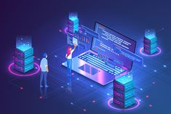

Google Services :

**Google cloud storage:**

It is a cloud storage service provided by Google that allows you to store and retrieve your data securely and reliably. It offers features such as scalability, durability, and global accessibility, making it a great choice for businesses and individuals who need to store and manage large amounts of data.

**Google cloud computer engine :**

This is a cloud computing service offered by Google that enables you to create and run virtual machines in the cloud. It provides you with the flexibility to choose the type of virtual machine that suits your needs, whether it's a standard instance or a custom instance with specific configurations. With Google Cloud Compute Engine, you can easily scale your computing resources up or down based on demand, making it ideal for businesses that require high-performance computing or need to handle variable workloads.

**Google cloud AI platform :**

The Google Cloud AI Platform is a comprehensive platform that allows developers and data scientists to build, deploy, and manage machine learning models at scale. It provides a wide range of tools and services for every stage of the machine learning workflow.









Google Drive:

It's a cloud-based storage platform that offers users a place to store their files securely. With Google Drive, you can upload and

store various types of files such as documents, photos, videos, and more. It provides a generous amount of free storage space, and you can also purchase additional storage if needed.

One of the great features of Google Drive is its ability to sync your files across different devices. This means that you can access your files from your computer, smartphone, or tablet, as long as you have an internet connection. It's really convenient because you don't have to worry about transferring files manually between devices.

Google Drive also offers collaboration features, which allow you to share files and folders with others. You can give specific people access to view or edit your files, making it easy to work on projects together. It's a handy tool for team collaborations or sharing files . This means that you can create, editwith friends and family.

Additionally, Google Drive integrates seamlessly with other Google services like Google Docs, Sheets, and Slides, and collaborate on documents directly within Google Drive. It's a fantastic productivity tool for both personal and professional us.

Git and GitHub: Architecting Code Collaboration:

**Understanding Git:**

Navigating Version Control **Branching Strategies:**  Imagine Git branches as different storylines in

a book. Each developer can work on their part without messing up the main plot. This section

guidesyou on the best ways to manage these storylines effectively.

**GitHub: The Social Coding Hub:**

Picture this as a group project. Pull requests are like presenting your contribution to the team, and

code reviews are the team giving feedback. It's the collaborative heart of GitHub where everyone has

a say in making the final product better.

**Conflict Resolution Techniques :**

Just like in any team project, conflicts may arise when different people work on the same thing.

Git provides strategies to resolve these conflicts peacefully, ensuring your codebase stays harmonious.

**GitHub Actions for Automation :**

GitHub Actions is like having a personal assistant for your coding tasks. It automates routine jobs,

like checking your code's spelling or running tests, so you can focus on the creative part of coding.

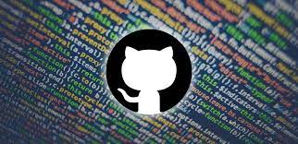

 Microsoft Tools :

Microsoft Teams provides robust features for virtual meetings and collaboration, including high-quality video/audio, interactive tools and security measures.It enhances productivity through persistent chat channels,real-time co-authoring, task management, and integration with popular apps. The platform promotes increased flexibility, reduced costs, and improved communication within distributed teams. Additionally, Teams serves as a customizable ecosystem, integrating seamlessly with third-party tools and allowing personalized customizations for enhanced efficiency, improved collaboration, increased productivity, and greater flexibility in adapting to specific workflows.

Accessibility tools in Microsoft Office address:

For visual impairment, there are screen readers, text-to-speech, and high contrast themes. Mobility limitations are tackled with keyboard shortcuts, dictation, and zoom/magnification. Cognitive accessibility features include language options, focus guides, and the Immersive Reader. General accessibility encompasses alternative text, closed captions, and color scheme customization, ensuring inclusivity for different users.

The incorporation of TIC on project management :

**Improves overall efficiency :**

TIC encompasses a range of tools and systems that streamline communication, data management and project workflows.

**Enhanced Communication :**

TIC technologies offer communication tools like video conferencing, instant messaging and collaborative platforms.

**Centralized Data Management :**

Integrating TIC tools enables storage and access to project related data. This reduces the risk of information silos. Ensures that all team members have access to the up.

**Collaborative Platforms :**

TIC technologies often include platforms where team members can work on documents simultaneously share updates and provide real time feedback.

**Task Automation :**

Incorporating TIC in project management often involves automating tasks reducing effort and minimizing errors. This may include automated updates, notifications or reminders to ensure completion of tasks.

**Managing Projects Remotely :**

TIC technologies enable project managers to efficiently supervise and control projects even when team members are operating from locations. This adaptability proves beneficial in the present day dynamic work setting.

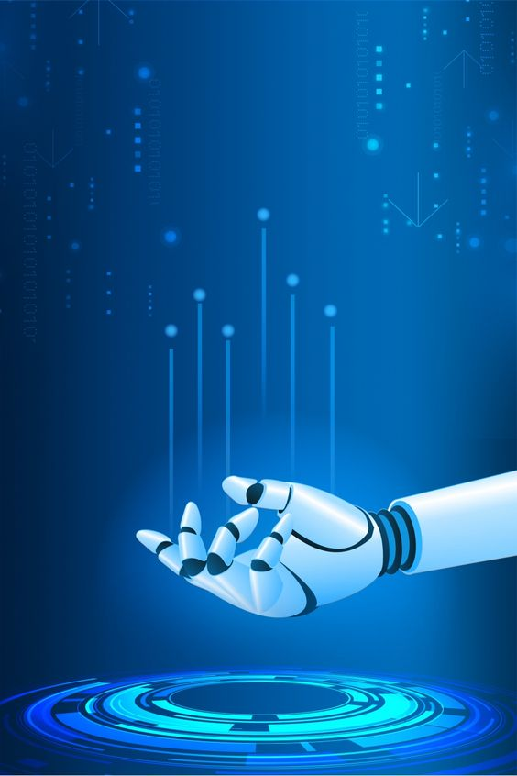Artificial Intelligence:   
 A New Landscape or a New Era

**AI and cognitive services, once confined to science fiction, are now integral to our everyday reality. AI's role in the Fourth Industrial Revolution stems from the exponential growth of "datafication." The shift in AI research from academic-driven to economically and socially motivated is noteworthy. AI's impact on fundamental rights and freedoms, challenges related to opacity, and ethical considerations are essential aspects.**

 THE BLOCKCHAIN TECHNOLOGY :

**Blockchain technology, initially designed for cryptocurrencies, has evolved into a revolutionary force in information security. The report explores the impact of blockchain on security measures, examining key components and applications in secure data storage, identity management, supply chain security, and cybersecurity auditing. Challenges related to scalability, the regulatory landscape, and integration with existing systems are discussed.**

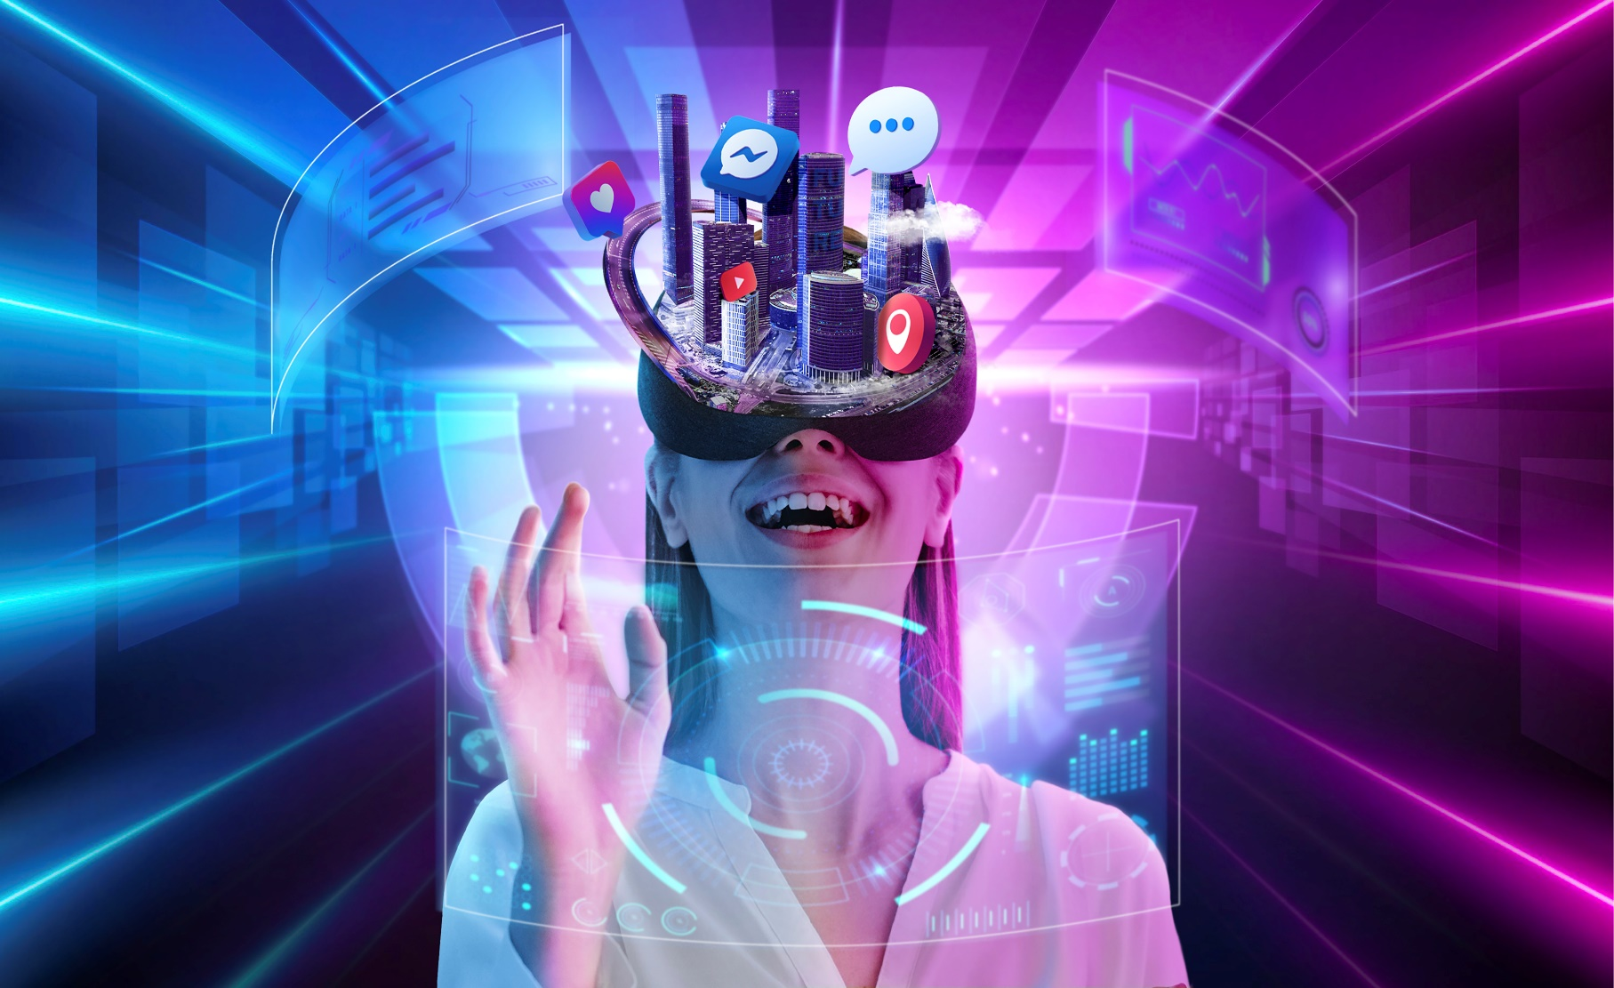

**Augmented Reality:   
Transforming User Experience**

**Augmented Reality (AR) seamlessly integrates digital information into the real world, revolutionizing user experiences. The report covers the key components of AR, including sensors, display technology, and**

**computer vision. Applications range from enhancing the retail experience and immersive gaming to education, training, and healthcare**

 conclusion :

**the convergence of Information and Communication Technologies (ICT) with innovation and connectivity has indelibly transformed our world. With technology giants such as Google and Microsoft at the forefront, the landscape of communication,**

**information access, and project execution has been reshaped significantly. The advent of collaborative tools like Git and platforms like GitHub has revolutionized software development practices.**

**As we navigate through this digital era, it is evident that these technological advancements have seamlessly integrated into both our professional landscapes and daily lives. The intricate web of interconnected technologies, from Google services to Microsoft tools and version control systems like Git, has become the foundational fabric of our contemporary digital experience. This journey through the realms of connectivity and innovation underscores the profound impact of ICT on shaping our interconnected and digitized world. It prompts us to reflect on the ongoing evolution of technology and its ongoing influence on how we communicate, collaborate, and navigate the complexities of our modern society.**